**[Using the Time Aware configurable app template](https://blogs.esri.com/esri/arcgis/2016/07/27/using-time-aware-app-template/)**

‎Thursday, ‎28 ‎July ‎2016, ‏‎4:00:16 p.m. | Bern Szukalski

Map layers may contain temporal data—an attribute field containing the date and time that something happened. These temporal events can occur in the same place, or can occur in different places, over the course of time. For example, the recorded stream flow at a gauging station does not change location, but the stream flow gauge values do. Earthquakes, fires, and crime incidents occur at different locations over time.

In the web map, temporal data can be visualized using a time slider. The time slider provides controls to explore temporal data interactively and is available at the bottom of any map that contains enabled temporal layers.

[Time Aware](http://www.arcgis.com/home/item.html?id=b70d83ba89db4f8a97427ee237a1e60c) is a configurable app template that enables users to visualize time-enabled layers. It enhances the temporal capabilities of the web map, and can be configured to display time-enabled web maps in different ways.

Here’s how to use Time Aware, beginning with adding data and authoring the map that will be used. If you already have a time-enabled map, skip to Configuring Time Aware.

**Timely data**

In this example, earthquakes events exceeding 5.5 in magnitude for the year to date were downloaded in CSV format from the [USGS Earthquake Archives](http://earthquake.usgs.gov/earthquakes/search/). Inspecting the CSV we can see the date and time of the quake are stored in the Time field (and that the file includes lat/long).

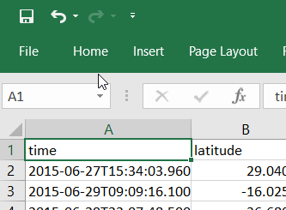

The CSV file used in this example can be [downloaded here](http://www.arcgis.com/home/item.html?id=a13a7c98be4c45b3ab3bbf14f32d80f9).

**Create a time-enabled layer**

To make a time-enabled layer that will be used in the map and the Time Aware app, follow these steps.

1. In My Content, add the CSV file by clicking Add Item, then choosing From my computer.

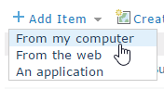

2. Click Choose File to browse for the file.

3. Add a title and tags.

4. Publish the file as a hosted layer. Note that this requires publisher privileges, you can skip this step and [start with the layer](http://www.arcgis.com/home/item.html?id=1436bf1bc4d14262980cdd22f21070dd).

5. Click Add Item.

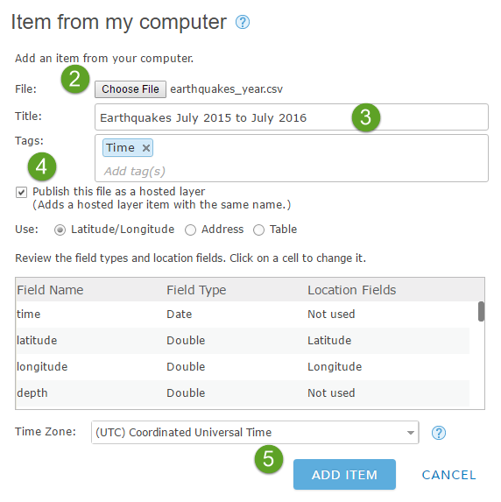

6. After adding the item, click Time Settings in the Layers section on the Item Pages.

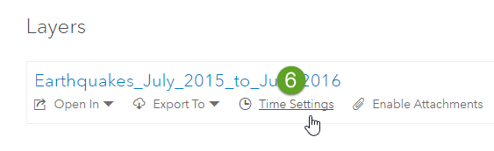

7. In Time Settings, check Enable Time.

8. Choose the time field to use (in this case it is *time*).

9. Click OK.

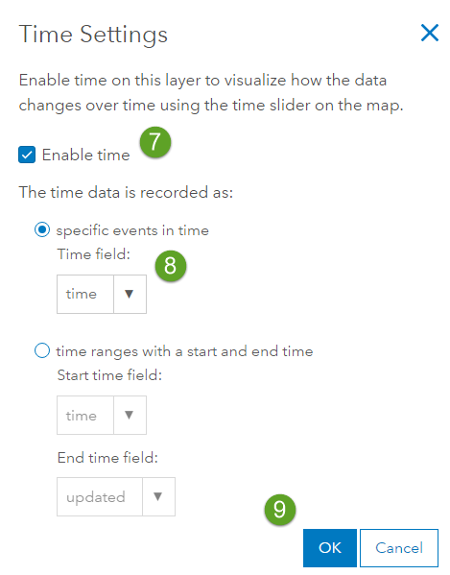

Save the changes you’ve made to the itme. You’ve now created a time-enabled layer.